**CHALLENGE**

* Breakdown of the Kawasaki engine side thruster
* The customer was looking for a genuine and component service provider because the **OEM was not available to do the overhaul**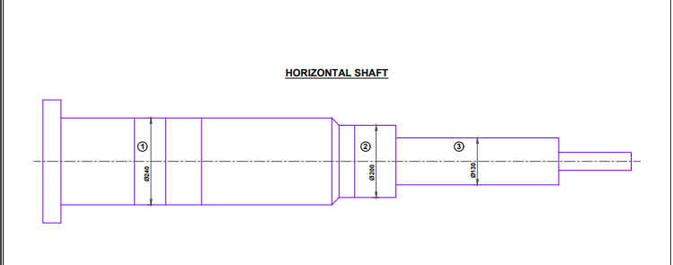
* The overhaul was a time constraint and the identification and validation of the spare parts were needed as it was taken from the **second-hand vessel.**
* **Neptunus never did the overhauling of the Kawasaki engine before** and the job required us to supervise another maintenance team with whom we had never worked before

**SOLUTION**

* Neptunus’ service team assessed the situation and did the risk assessment. We were confident enough to complete the assignment due to our level of expertise in **overhauling 50+ vessels.**
* Accordingly, the following tasks were completed by the vessel engineering team:

1. Studying the manual of the engine
2. **Authenticating the spare parts**
3. Drawings prepared for surveyor approvals and certification completed
4. Creation of the technical as well as commercial documents to supervise the maintenance team

* We completed the overhaul and received the appreciation letter from the customer and they will prefer Neptunus for their upcoming projects soon.

**BENEFITS**

* If the problem would not have been resolved immediately, the vessel could have been off-hired for 4 weeks. So with a timely solution, Neptunus **saved a potential loss of revenue of ~$40,836** (assuming 30 days of off-hire)
* The customer **saved ~$6125** for the overall service charges by opting for our service which is fairly reasonable if compared to the OEMs.

**CUSTOMER TESTIMONIAL**