**CHALLENGE**

* On 20th May 2020, the chief engineer of the vessel 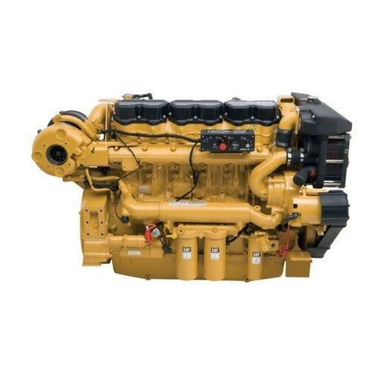

sent a **SOS email** to Neptunus **for resolving**

**a critical problem on the auxiliary engine** of the

subject vessel. The engine was frequently tripping

& the vessel engineering team could not fix it onboard.

* Though this was an auxiliary engine, for operation of

Bow Thruster (BT), it was necessary to have this engine

in proper running condition, else the **vessel could have**

**been de-hired leading to substantial loss.**

* **Due to lockdown** situation, Neptunus’ service team

was **unable to travel to attend to this problem**

**SOLUTION**

* Neptunus has been a **preferred partner** to Triton for engine maintenance across their multiple vessels
* Neptunus’ service team assessed the situation, **studied the symptoms** after discussions with the vessel engineering team and **quickly made a “checklist” to trace the possible root-cause.**
* Accordingly following was checked by the vessel engineering team
  1. After restarting the engine, what is the voltage value?
  2. Had they flashed the Exciter?
  3. What is the winding resistance & insulation value?
  4. Have they done the visual Inspection of the rotating rectifier assembly?
* **Within 12 hours** of first reporting the problem, **the root cause was found** in the loose bolts of the rotating rectifier assembly & problem was resolved soon after. The **engine started running smoothly** without tripping.

**BENEFITS**

* If the problem would not have been resolved immediately, the vessel could have been off-hired. So with a timely solution, Neptunus **saved potential loss of revenue of ~$ 35,000** (assuming 7 days of off-hire)
* The remote support provided by Neptunus’ service team also **saved the additional charges** of alongside-docking of vessels and deployment of service engineers, **totaling to ~$ 2,000.**

**CUSTOMER TESTIMONIAL**

*“Appreciate your quick response and suggestions. I would like to inform you that the problem has been traced by the ship staff and rectified. The rotating rectifier assembly cables were found partially damaged because the rectifier plate holding bolts were in loose condition. Other checks on the engine were satisfactory.”*

* **Capt.Pankaj Singh/Mr. Kaushal Kishor, Master/Chief Engineer (India Operations)**