**CHALLENGE** 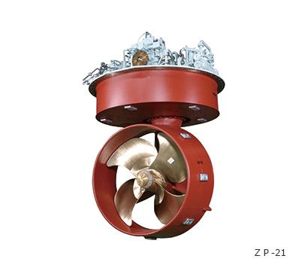

* Greatships Prachi, the offshore service

vessel was to be deployed on a new offshore

platform duty in 20 days

* An overhauling of the **Niigata make ZP41**

**Z-peller assembly was due for overhauling**

before new assignment

* Standard time needed for overhaul was 30

days (or even more sometimes) which meant

a possible **delay in deployment** that would have

costed a **huge LD payment** to Greatships

**SOLUTION**

* Neptunus has been a **preferred partner** to Greatships for engine maintenance across their multiple vessels
* Greatships team approached Neptunus and explained the challenge. The expectation was to complete the overhauling assignment on an expedited basis within the **targeted time of 20 days**
* Neptunus quickly did the planning and mobilized the team with extra manpower to expedite the job.
* Neptunus’ back office team took care of the coordination with Greatships team and L&T Shipyard team (where the vessel was docked)
* All necessary spare were readily made available from Neptunus’ stock inventory to save on time

**BENEFITS**

* Entire assignment was completed in 16 days, 25% faster than the challenging targeted completion date
* Greatships could utilize the extra 4 days saved to complete other maintenance tasks and testing of vessel
* The vessel could sail for the deployed task right on time
* **The planning, coordination and urgency shown by Neptunus helped Greatships save ~ $50,000 of LD charges**

**CUSTOMER TESTIMONIAL**

*“We rely on Neptunus as a preferred partner for the engine and z-peller maintenance because of knowledge, experience & skills of their expert service personnel. Recently they performed the overhauling of Niigata ZP41 Z-peller on our vessel ‘Greatship Prachi’ in under 20 days (usually takes 30 days or more) We appreciate the exemplary technical skills, planning, coordination, and customer centricity of Neptunus’ team.”*

* **Somesh Ugra, DGM, Greatship India Limited, Mumbai, India**