**CHALLENGE**

* **High cost of new lube oil** due to frequent oil changeson CAT diesel engines onboard the land rigs.
* **Over ~$ 558,000** being spent on oil change over the 3 years contract period.
* **Lube oil contamination** was a frequent issue, despite timely change of oil as well as inline filters on the engine.
* **Long response time** (typically 3-4 weeks) for lab reports on oil samples, and t**he data by then is outdated.**

**SOLUTION**

* Neptunus studied the current operating practices and suggested use of Oil Quality Management solution (OQMs) comprising of a hi-efficiency continuous bypass kidney loop oil filtration system for oil cleaning and online oil quality monitoring sensor to measure composite oil quality and remaining useful life (part of Neptunus’ Asset Reliability Management solution) so as to decide on the oil change. These sensors were connected through IoT to a cloud-based remote monitoring dashboard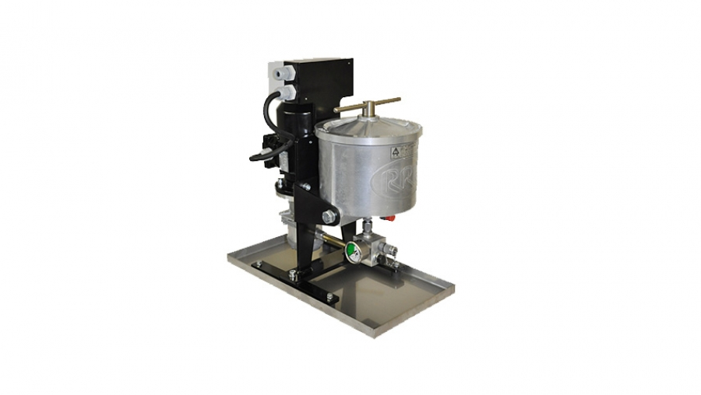
* The OQMs was deployed on all 4 engines onboard 1 rig as a proof of value and run for the 1000 hours cycle, which was typical prevailing oil change interval. The oil quality shown by the sensor was good, but as a confirmatory test, the oil samples were also sent for a lab analysis which confirmed that the quality of the oil is well within usable limits. The same test was repeated after 2000 and 2500 hours intervals. 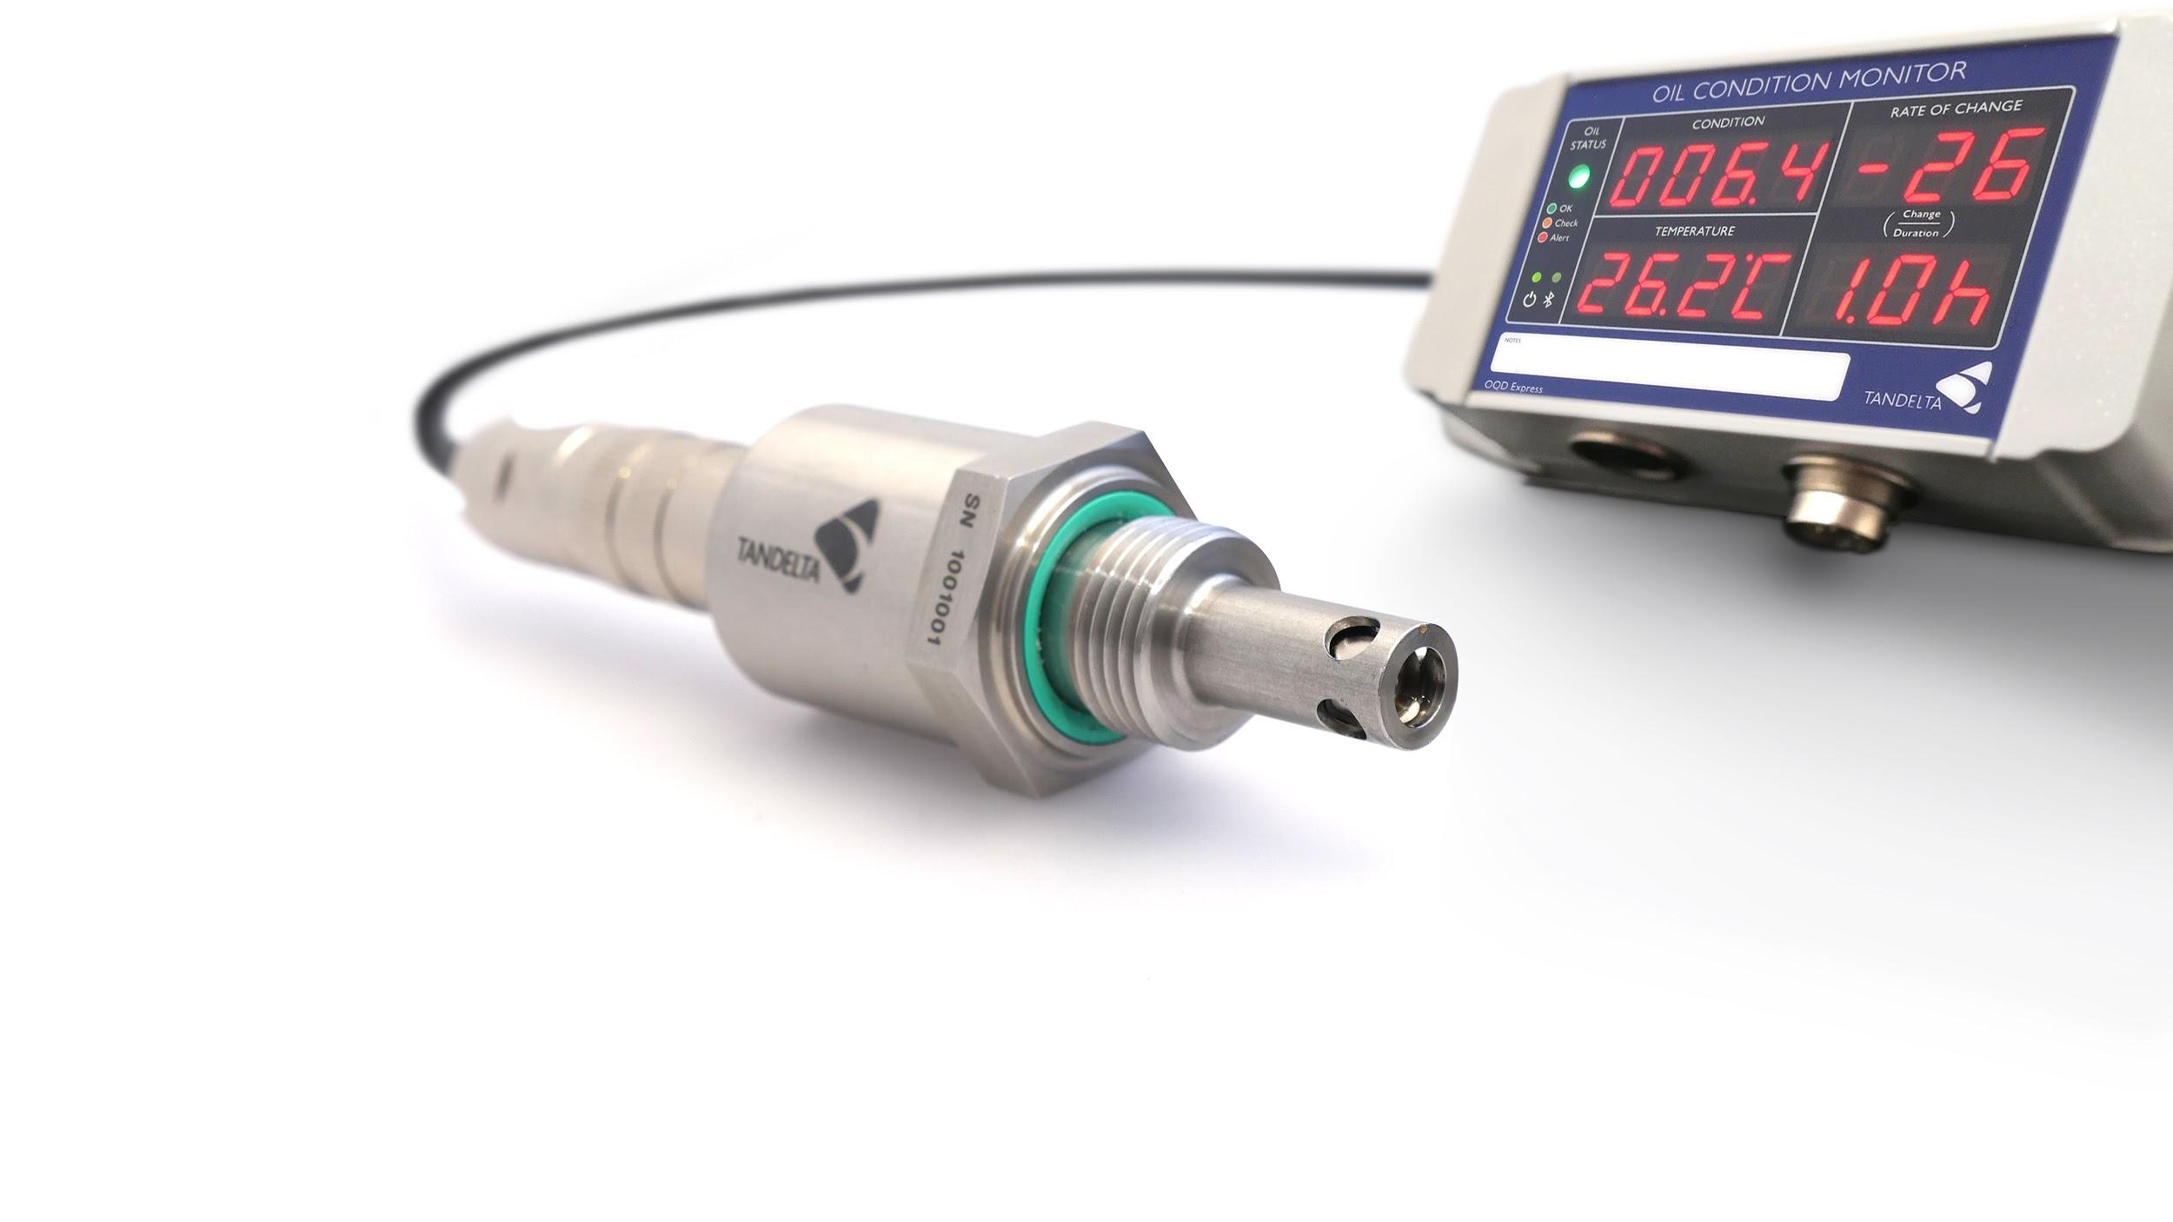
* Based on the results, the customer made a **confident data-backed decision** to **extend the oil change interval to 2500+ hours.** This was **2.5 times more than the standard interval** followed by the customer in the past.

**BENEFITS**

* **Actual Direct savings achieved on one rig (4 engines)**, calculated on yearly basis over the initial 12 month period

of deployment of solution **= ~$3715/engine = ~$14,860**

* **60% saving** on oil related direct OPEX (cost of oil change + inline filter change)
* **For all 21 rigs, projected savings potential over the 3 year contract period = ~$936,000**
* **Further saving with lesser OPEX** (engine maintenance, logistics for disposing of dirty oil) & **higher rig uptime**