**CHALLENGE**

* **Repeated breakdowns on the 7 nos Caterpillar engines** (Series 35 & 34) across the 11 land rigs
* These breakdowns were **impacting the drilling performance.**
* A local service provider advised **Top End Overhaul on 3 nos. 3512 & some repair activities like injector replacement, turbocharger replacement, cylinder head replacements on the other engines.**

**SOLUTION**

* Neptunus’ expert **advised for Engine Health Diagnostics using torsional vibration analysis**. The objective was to ascertain the problem & recommend the **optimal servicing and spare parts to prevent the breakdowns.**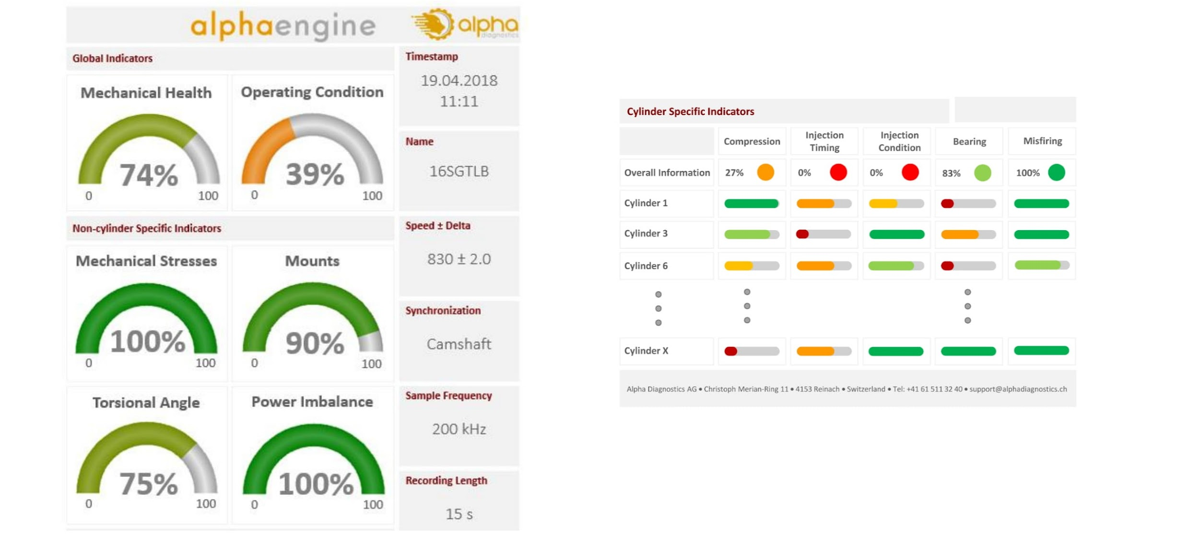
* Neptunus’ team went onboard & carried out the engine health inspection through **torsional vibration tool**
* The report data showed that **only one 3512 engine needed a Top End Overhaul & MTBO (Mean Time Between Overhauls) for the other two 3512 could be extended by 2000 hours with minor repairs. The other engines could be repaired only replacing the specific faulty components** like injectors, turbo cartridges, dampers & by doing the calibration of fuel pumps
* Neptunus' team **proposed an optimized list of spare parts** which had fewer parts than the estimate of the local service provider. The job was completed by Neptunus on time and since then, these **engines have been running without breakdown.**

**BENEFITS**

* Since MTBO was extended by 2000 hours (20% extension), life cycle cost was reduced by (⅕)*$50,000 per engine = $10,000 per engine, **resulting in savings of $20,000 for two engines.**
* The repair saved 10 days compared to overhaul, and **breakdowns were completely eliminated.**
* The **drilling performance improved.** Rigs were able to complete wells on time & the **charterer** extended the contract of one rig by a period of 6 months .**This enabled revenue of 180 days * $5,000 = $900,000**