**CHALLENGE**

* 2 nos. EMD 12V-645-E8 engines were **due for a 30K hours overhaul** but the rig owner had a **budget constraint.**
* The **new drilling contract** for this rig was finalized and the **commissioning was due in a short time**.
* Technical team was **uncertain about the health of the engines** to go with the new contract

**SOLUTION** 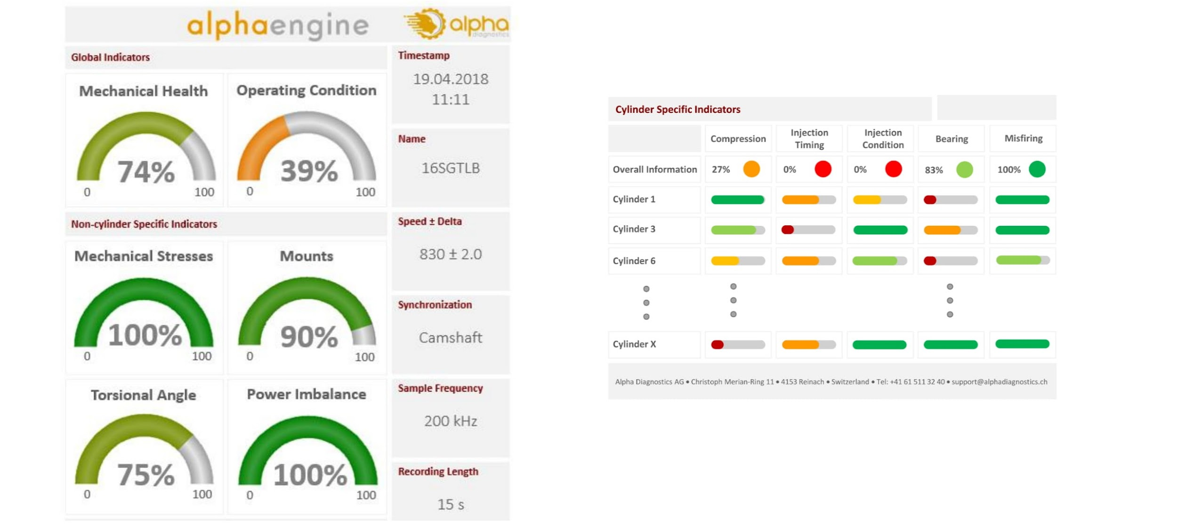

* Neptunus has been a **preferred partner** to this customer for engine maintenance across their multiple rigs
* Neptunus’ expert **advised for pre-overhaul diagnostics using torsional vibration analysis**. The objective was to **optimize the spare parts and consumables** needed as against the standard 30k overhaul costs
* Neptunus’ team went onboard & carried out the engine health inspection with our **torsional vibration tool.**
* The report data showed that the **condition of the inspected engines was satisfactory** for operating, and the **overhaul could be extended by at least 2000 hours.**
* This data helped the customer **confidently get into a new contract without doing an overhaul.**
* Eventually, the overhauls were **safely extended to 36000 running hours.**

**BENEFITS**

* Customer was able to depute the rig on time, instead of a potential 2 month delay. **This enabled revenue of 60 days * $25,000 = $1.5mn, and better cash flow management.**
* Since MTBO (mean time between overhaul) was extended by 6000 hours (20% extension), life cycle cost was reduced by (⅕)*$160,000 per engine = $32,000 per engine, **resulting in savings of $64,000 for two engines.**
* **Cost of capital at 10% of $320,000 for one year = $32,000.**
* Since MTBO was extended, **the Customer saved ~$10,000 on logistics and manpower costs** since overhauls did not need to be done in offshore drilling positions.
* It allowed the rig and technical teams to **focus on the core drilling operations rather than worry about the uncertainty of engine reliability.**