**CHALLENGE**

* A Caterpillar 3516B engine was **due for the 2nd Top End Overhaul as per the OEM recommendation**

**based on the running hours,** but the rig owner had a **budget constraint**

**SOLUTION**

* Neptunus has been a **preferred partner** to this customer for engine maintenance across their multiple rigs
* Neptunus’ expert **advised for pre-overhaul diagnostics using torsional vibration analysis**. The objective was to **optimize the spare parts list, consumables, manpower and downtime** of overhaul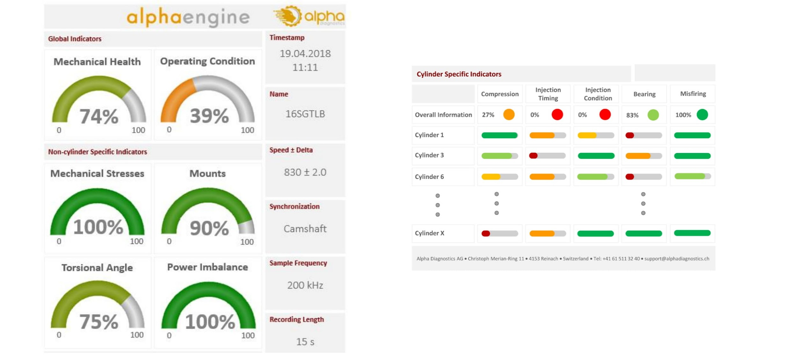
* Neptunus’ team went onboard & carried out the engine health inspection through **torsional vibration tool**
* The report data **showed issues with the fuel injection quality and the crankshaft main bearings**. Other health parameters were within acceptable limits. Based on this data, **Neptunus recommended only a Top End Overhaul** **instead of a 2nd Top End Overhaul**
* The diagnostic findings were reaffirmed when the engine was dismantled for a Top End Overhaul. The hatch marks on the liner & cylinder bore dimensions were observed to be in limits as per the OEM recommendation.
* **Engine has been running smoothly for over 6000 hours after the Top End Overhaul**

**BENEFITS**

* **Direct savings of ~USD 52,000** due to lesser cost of overhaul.This **increased the profitability** of the rig.
* We **saved 4 days due to the reduced scope** (8 days vs 12 days)thus expediting the rig repair project.
* It allowed the rig and technical teams to **focus on the core drilling operations rather than worry about the uncertainty of engine reliability.**