**CHALLENGE**

* **High cost of new lube oil** due to frequent oil changeson 5 CAT diesel engines onboard an offshore rig
* **Long response time** (typically 8-10 weeks) for lab reports on oil samples, and t**he data by then is outdated.**
* Based on their previous experience, the rig team was manually extending the oil change interval from the OEM

recommended 1000 hours to 2000 hours. **However this was not a data-backed decision** and lube oil contamination was frequent.

* The team regretted the **lack of real-time visibility of the oil quality.**
* **~USD 80,000** was being spent on new oil over the 3 years contract period.

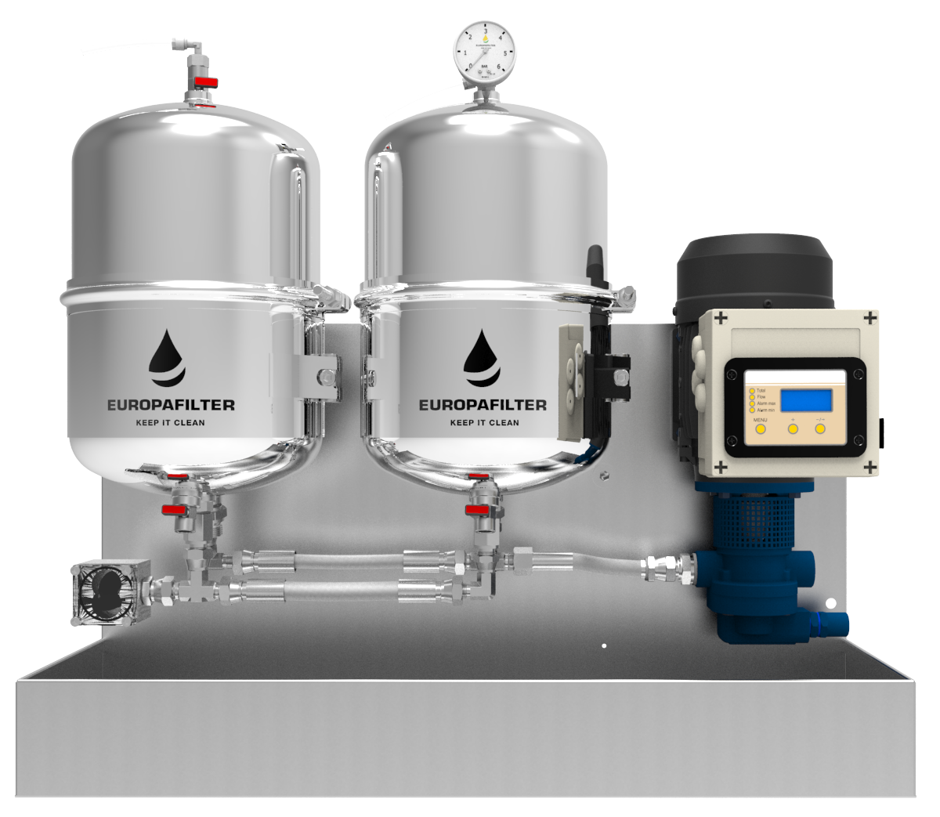

**SOLUTION**

* Neptunus has been a **preferred partner** to this customer for engine maintenance across

their multiple rigs

* The Customer deployed Neptunus’ **offline filtration system in a kidney-loop configuration**

on one rig.

* This **filter with a high beta Ratio of 929 had an effective capability to filter upto 3 micron contaminants along with the moisture and soot.**  This system is part of **Neptunus’ Asset Reliability Management** solution. 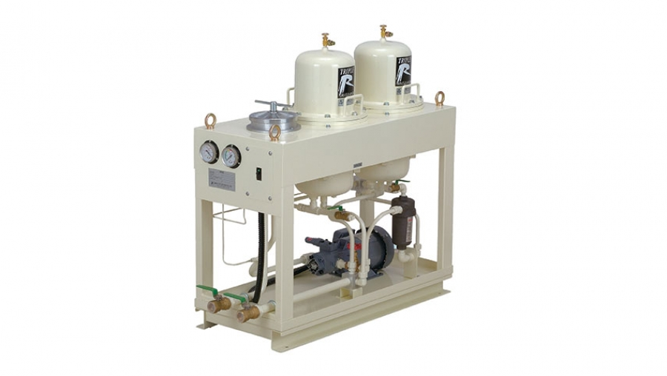
* This solution helped the customer make a **confident decision backed by real-time data** to

**extend the oil change interval by a factor of up to 4500 hours while enhancing the reliability**

**of engines.** This was 4.5 times of the standard OEM interval, and 2.25 times of the existing

practices.

**BENEFITS**

* Cleaner lube oil leads **to fewer breakdowns or failures.** Lube oil related issues cause 54% of machine failures. (Ref: Noria Corporation)
* **Cleaner components lead to extended MTBO (Mean Time Between Overhauls), less spare part consumption.** According to the ISO Cleanliness Code, cleaning lube oil from 20/17 to 17/14 increases diesel engine **component life by 2x.**
* Actual **savings on lube oil changes** and i**nline filter changes** on 1 engine over 1 year period **~$4000**
* **Projected savings** for one rig if deployed on all 5 engines over a 3 year contract **~$60,000**
* **Saving logistical hassles of disposing dirty oil, while being environmentally responsible.**