**CHALLENGE**

* 7 vessels were due for a major overhaul as per OEM’s maintenance cycle at 24,000 running hours which would have cost the customer $2,50,000
* Along with the cost this major overhaul would have cost the customer about 18-20 days of downtime for each vessel, resulting in loss of revenue
* The life-cycle of each vessel is around 20 years, approximately 65,000 running hours, meaning 2 MOH have to be performed for each vessel before it’s scrapped.

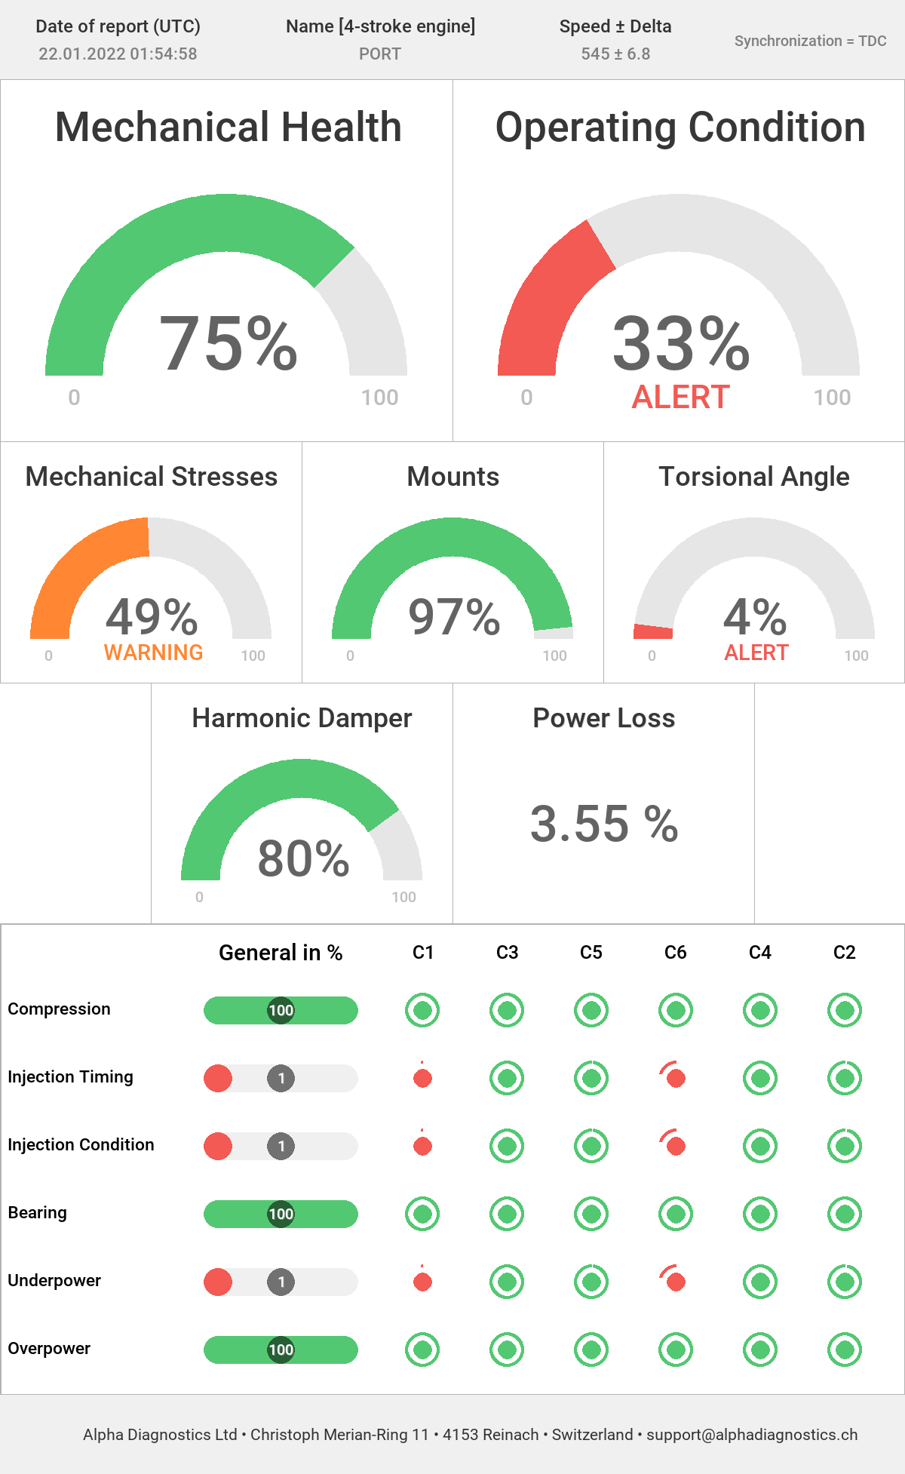

**SOLUTION**

* The Customer deployed Neptunus’ **engine condition monitoring system** (part of Neptunus’ **Asset Reliability Management** solution) on all 14 engines of their 7 tugs for an engine health checkup which was already above 24,000 running hours
* Neptunus did the engine health check without opening up the engine and with the help of **2 sensors only we submitted a conclusive report which indicated to replacing only 2 injectors on a couple of their tugs and they can run further without a major overhaul**
* This helped the customer make a **confident data-backed decision, replace only the required parts and extend the major overhaul**
* **With the extension of 1st MOH, the customer is able to eliminate 2nd MOH in life-cycle of these vessels**

**BENEFITS**

* Customer was able to see **in-depth report cylinder-specific, do the necessary scope needed at bare minimum cost**
* With this approach, the customer is able to **eliminate 2nd MOH thus resulting in huge savings of $1,00,000 for each vessels**