**CHALLENGE** 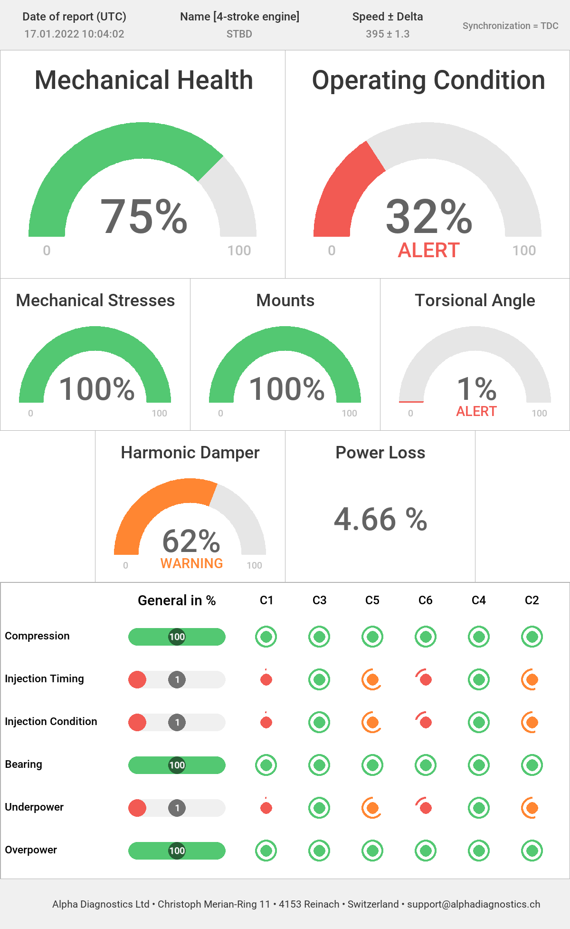

* This vessel was due for a major overhaul as per OEM’s maintenance cycle at 24,000 running hours which would have cost the customer above $100,000
* The life-cycle of this vessel is around 20 years, approximately 65,000 running hours, meaning 2 MOH have to be performed for this vessel before it’s scrapped. This results in huge expenditure for the customer on overhauls
* The customer has a target of keeping the vessel uptime above 98%

**SOLUTION**

* After the 1st health checkup, there were some concerning areas on the injection front. We proposed customers do continuous engine monitoring so that they have real-time engine condition data and without any risk, they can extend the overhaul with the **replacement of 2 injectors costing just $5,000**
* The customer’s onboard team, as well as their office team, **can view the engine condition on a real-time basis and have full control over their engines**
* With the real-time condition monitoring **we propose to do only bare minimum scope required (In this case injectors) based on the real-time engine condition monitoring and push the MOH further** and still retain the reliability of the engine

**BENEFITS**

* **Customer is able to see real-time engine condition, cylinder-specific and take a data-backed decision**
* With the extension of the major overhaul, the customer is able **to eliminate the whole 2nd MOH in the life-cycle of this vessel**
* They were able **to save 20 days downtime on MOH service which would generate them a revenue of $30,000 along with meeting their target of above 98% uptime**