**CHALLENGE**

* **High cost of new lube oil** due to frequent oil changeson 5 CAT diesel engines onboard an offshore rig
* **Long response time** (typically 8-10 weeks) for lab reports on oil samples, and t**he data by then is outdated.**
* Based on their previous experience, the rig team was manually extending the oil change interval from the OEM recommended 1000 hours to 2000 hours. **However this was not a data-backed decision** and lube oil contamination was frequent.
* The team regretted the **lack of real-time visibility of the oil quality.**
* **~USD 80,000** was being spent on new oil over the 3 years contract period per rig.

**SOLUTION**

* Neptunus has been a **preferred partner** to this customer for engine maintenance across their multiple rigs 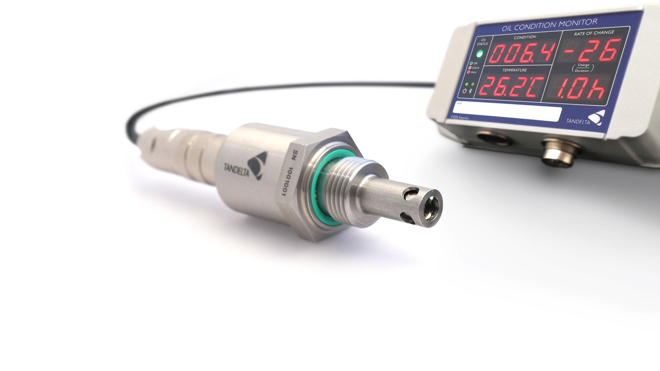
* The Customer deployed Neptunus’ **online oil quality monitoring sensor** (part of Neptunus’ **Asset Reliability Management** solution) on all 5 engines of 4 rigs.
* This sensorinstalledin the oil line continuously monitored oil quality and displayed **overall oil quality index** (combined reflection of 22 parameters like viscosity, moisture, oxidation, particles etc.), **temperature** and the **remaining useful life** of oil. Using IIoT interface & cloud, this data can also be remote monitored & trended.
* This helped the customer make a **confident data-backed decision** to **extend the oil change interval to 3300+ hours.** This was 3 times the standard OEM interval, and 1.5 times of the existing practices.

**BENEFITS**

* **Early warning of lube oil contamination!** Lube oil related issues cause 54% of machine failures and these are potentially prevented by real-time monitoring. (Ref: Noria Corporation)
* **On one rig, actual savings over initial 12 month period of deployment of solution = $1800/engine = $9000**
* **Benchmark savings** over the standard OEM oil change recommended interval **per engine ~$110,000** (67% saving of standard lube oil spend per engine of $160,000 over 3 years)
* **For 4 rigs, projected savings** for this Customer over the 3 year contract = **~$108,000**
* **Saving logistical hassles of disposing dirty oil, while being environmentally responsible.**